Instructional Program Review Team Hub

Access Instructions

This document is provided to assist programs in accessing the Instructional Program Review hub. If you have any questions, please contact Sherry Davis at shdavis@hillcollege.edu or 254-659-7818.

Training on the hub can be provided.

- What is Program Review Hub: Digital (Microsoft Teams) application within Microsoft 365 used to organize and communicate with groups of people.
- What does Hill College use it for?: The Office of Institutional Effectiveness utilizes Microsoft Teams to organize, communicate and access documents for institutional effectiveness purposes. Teams put all documents such as program reviews, annual follow-ups, Perkins tracking and other documents in one location.
- How to Access
  - Number 1: Do you have a Microsoft 365 account through Hill College?
Yes, I have a Microsoft 365 Account | No, I don’t have a Microsoft 365 Account  (Must Complete First)
- An email is sent to invite you to Microsoft Teams  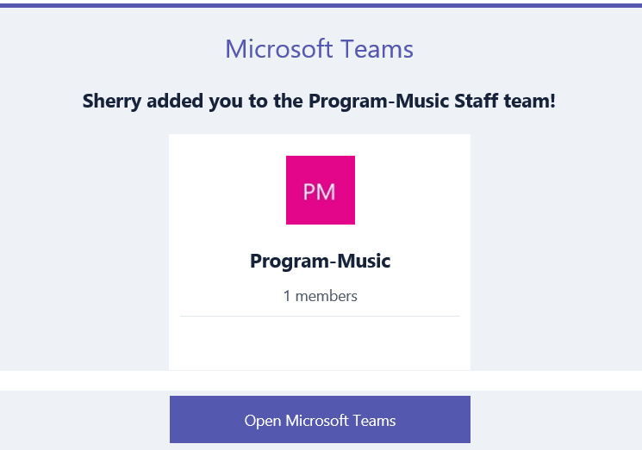  Click Open Microsoft Teams  - The next screen will inquire as to which way to access Teams. (1) Download the App to your computer, phone or tablet or (2) access through the web.  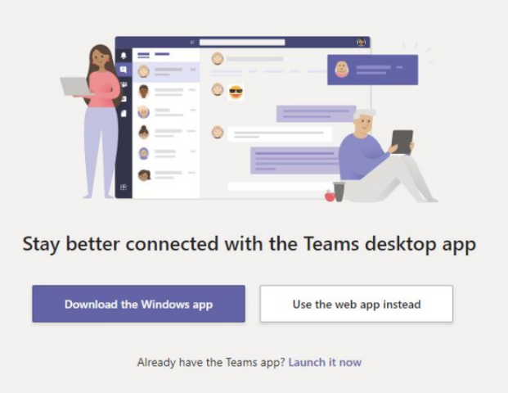  - Login in using your Microsoft 365 login. This is not the same as your Hill College login. | - Set up a Microsoft 365 Account.  - Hill College has enrolled in the Office 365 Education program that allows access to Office products plus other collaboration apps. The plan allows you to use on up to 5 devices.  - Click on Office.com/GetOffice365.  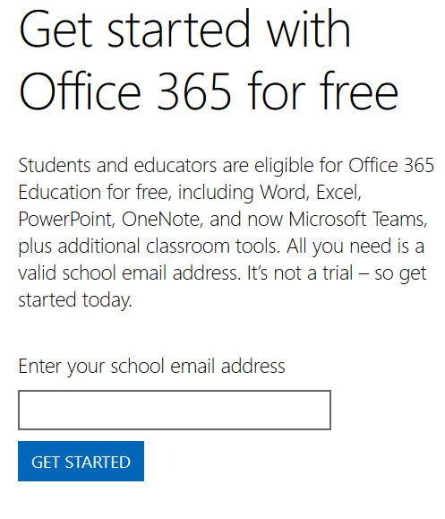  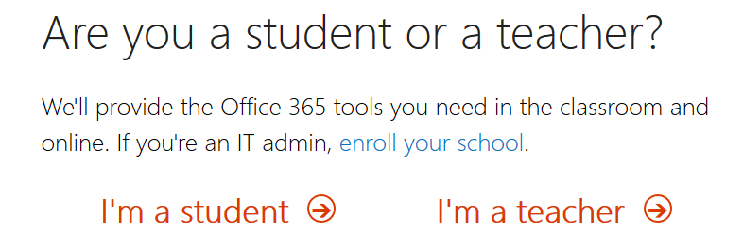  - Select I’m a teacher and follow the prompts to set up your account.  - Click through to download & sign in with your credentials (Enter your Hill College email address and click "Sign up". Once you receive your confirmation email, sign in with your Hill College email address, and download.  NOTE: If you do not receive your confirmation email, be sure to check your junk/spam folder).  IMPORTANT: Notify the Office of Institutional Effectiveness (Sherry Davis) so that you can be added to a Team account.  - The download site, select your language and click install  NOTE: You will need your school email account to sign in. If you don’t have your login information or have trouble, submit a help request to the IT department.  For Mobile Devices:  You can download from your App Store.  - Follow the “Yes, I have a Microsoft 365 Account” column to access Microsoft Teams

How To Find Team in Microsoft 365

- Step 1: Login to www.office.com using your Microsoft 365 login.

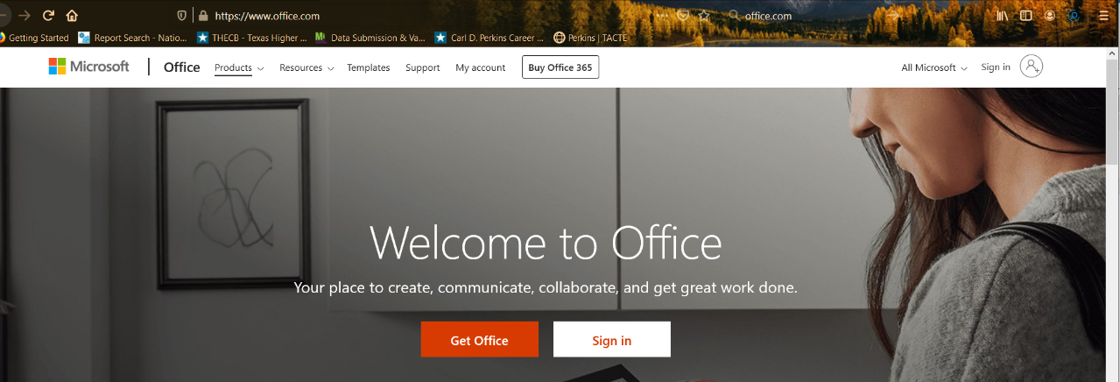
- Step 2: Login using your Hill College email.

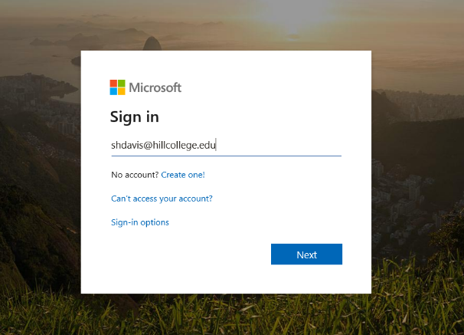
- Step 3: Indicate the account is a work account.

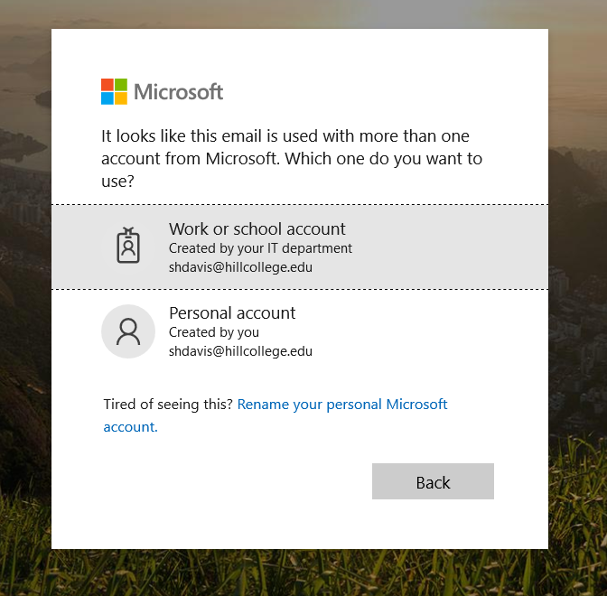
- Step 4: Put in your Microsoft 365 password (Password isn’t connected to the single sign-on. This password is one that the account user must keep track of and doesn’t change when you update your Hill College system password)

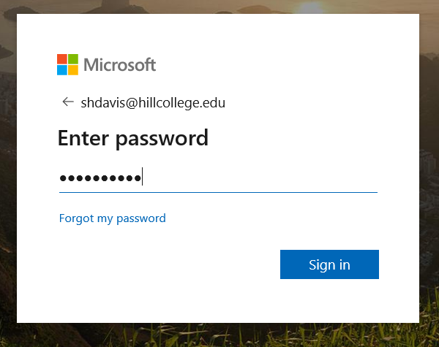
- Step 5: Indicate whether your want to have Microsoft keep you logged in (I always select no)

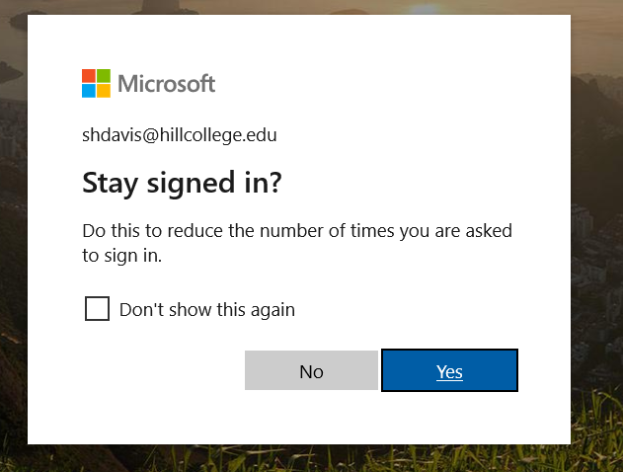
- Step 6: Locate the TEAMS icon

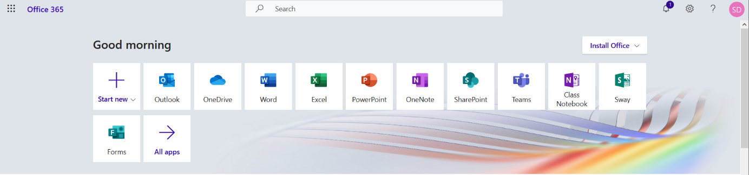

Teams Landing Page

If your program doesn’t show up, contact Sherry Davis at shdavis@hillcollege.edu or 254-659-7818 for an access code to join a team.

Joining a team: only does this once.

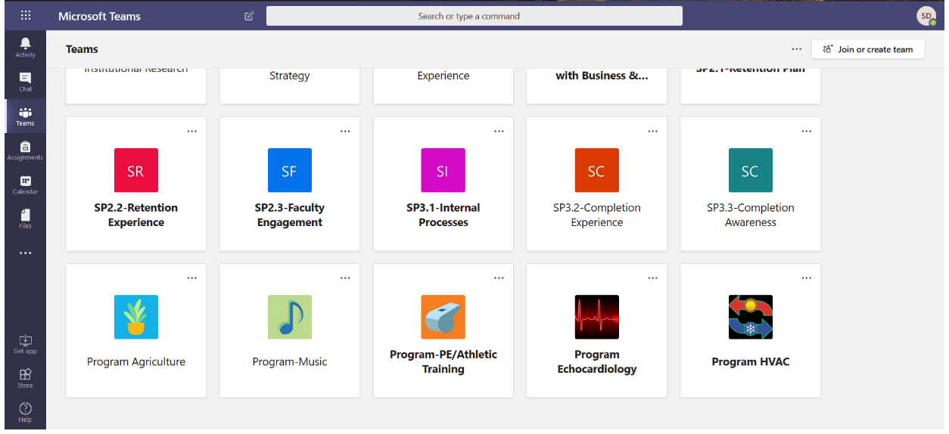
- Team Page

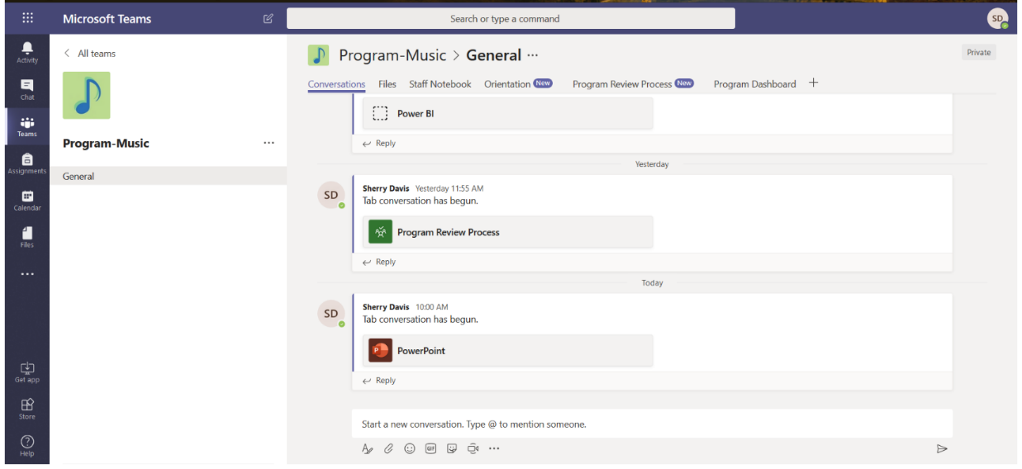

Conversations: Each member of the group can post comments or information. Conversations are like social media type frames.

Files: The Office of Institutional Effectiveness uploads documents pertaining to the program review. Additional documents can be loaded to the file area. In order to create a tab using a document, the document must be preloaded into the file tab.

Staff Notebook: This can be used to store program research or information compiled by group members.

Orientation: The Office of Institutional Effectiveness loads the Orientation PowerPoint for a resource to the program.

Program Review Process: This is a planning tool that can be used by the program to keep track of task and deadlines. To do items can be added as needed.

Program Dashboard: This page will link the group to the program data dashboards for institutional data about the program. Dashboard provide data on student demographics, course enrollments, course success rates, graduation and scheduling/sequencing of courses.

Questionnaire (Initial Review): Is is the document that must be completed prior to compression planning sessions. The document can be collaboratively worked on by multiple faculty if Coordinators so choose.

Initial Program Review: The Office of Institutional Effectiveness will post the final draft of the program review after approvals are received. Programs can refer back to the document as needed.

Annual Follow-up: The Office of Institutional Effectiveness post the active excel document for annual follow-up of task for programs to complete. The program has access to this as soon as the Program Review is final. Programs can updated task, delete or add task throughout the year.

Extra Information
- Each program has access to customize hub or add members to the team as needed.
- Teams has a mobile app that works well on cell phones or tablets. Easy to keep connected.

Need help with Teams or just want to see what you can do with Teams

Teams Tutorials Help Center

https://support.office.com/en-us/teams

Microsoft Support Help

https://support.office.com/

